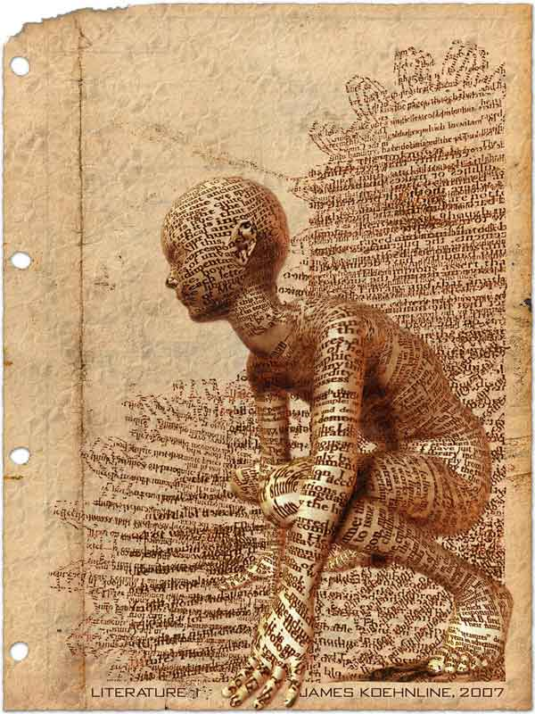
Creating a Literary Terms Handbook Entry:
an ongoing classwork/homework adventure…
NOT a project. ☺

THE BIG IDEA: There are hundreds of terms related to the study of literature and
language. We will spend the year delving into the strategies and techniques that are
most likely to help you with close reading, analysis, and your own writing. Authors use
multiple techniques and often layer strategies to achieve a certain effect – you need
to know as many terms as soon as possible in order for us to have meaningful
conversations about writing. Literary terminology (henceforth known as “lit terms”)
will make more sense to you if you discover them in writing, rather than being assigned a list to memorize.

THE TASK: Create a literary terms handbook that you can keep forever and ever. This can be a section of your binder or a separate folder full of terms – whatever works for you. You will NOT turn in the final handbook; rather, you will be graded on the individual entries that you create (sometimes as a class activity and sometimes as homework). Ultimately, your handbook will help you:
- Successfully identify terminology in future units of study
- Remember advanced devices (you will be allowed to use the LTH on specified quizzes and timed writings, + it makes a handy study guide for each semester’s final exam)
- Prepare for the AP Language and Literature exams
- Internalize and memorize the definitions for lit terms you will need to know in future high school classes and in college

ASSESSMENT: LTH entries will be graded for the following elements:
- Accuracy of definitions
- Appropriate selection of examples from summer and independent reading novels
(Life of Pi and The Ramayana/Siddhartha, for now)
- Thoughtful explication of quotation and clear connection to literary term definition

HOW TO CREATE AN ENTRY:
1. As you read, be on the look-out for interesting language and/or techniques. After the first read-through, go back and annotate for literary devices.

2. For each entry in your booklet, write the term and a brief but clear definition at the top of the page. Links to literary terms glossaries are provided at www.thewebsterweb.com.

3. Examples of each term must come from texts read for this class, i.e. Life of Pi, Ramayana, or Siddhartha. Copy the excerpt from the book into the left-hand column of a t-chart (I recommend that you create a table, and then use that template for all entries.

4. In the right-hand column of a T-chart, explain how the pulled passage is an example of the device, and how it impacts the reader (consider contribution to tone, mood, or theme).

Steps 1-4 earn you a 95. ☺

5. For a high A (96-100), provide an illustration of the term that will help you remember either A) the meaning of the term, or B) the scene in the book that illustrates the term. This final step is often the way that students finally internalize and memorize the meaning of a device.

Note: Sometimes LTH entries will be graded for content; at other times, they’ll be graded for completion. Always have your previous LTH entries on hand to assure me that you’re turning in a NEW term, and not one you’ve already submitted. Gracias!

THE TERMS:

Los Superseven: Figurative Language Devices:
Diction Metaphor
Imagery Simile
Detail Personification
Syntax Oxymoron
Point of View Synecdoche
Tone Metonymy
Theme Apostrophe (not the punctuation mark)
Hyperbole
Idiom

Meaning: Sound:
Allusion Assonance
Motif Consonance
Symbolism Onomatopoeia
Alliteration
Irony Syntax Techniques:
Satire Antithesis
Paradox Juxtaposition
Archetype Asyndeton
Polysyndeton
Ellipsis
Timing: Parallelism
Flashback Anadiplosis
Foreshadowing Epanalepsis
Anaphora
Epistrophe
Parallelism

EXAMPLE:

SIMILE: a comparison of two unlike things using “like” or “as”

Excerpt from The Ramayana | Explanation
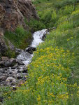  “…both beauty and youth are like a wild stream, which while rushing down the mountainside, crushing flowers and leaves, holds you in a spell” (40). |   In her efforts to incite Kaikeyi to action, Kooni compares beauty and youth to a stream that cannot be held back. She believes that Kaikeyi should use her strong womanly powers to convince Dasaratha to pass the crown to her son, Bharatha, before Kaikeyi is too old and saggy to have a meaningful impact on her husband. This is yet another instance in The Ramayana in which women are powerless save for their sexuality.

Note: Your bonus image can be something that reminds you of the term itself (see Simile-Man above) or of the moment in the book (see wild mountain stream crushing flowers). It can be hand-drawn or represented by images you find on the internet. You only need ONE image per term.
Name: __________________________________
The first four entries will be due on 10/23-24, but I want to check your progress along the way. Please have 2 completed entries by 10/21-22 to earn completion stamps.
Note: You may use this packet to hand-write your first four entries, or you may re-create the document on your own computer and print.
Date: ____________________ Period: _______

DICTION: ____________________________________________________________

Title of novel: | Title of novel:
Quotation + citation: | Quotation + citation:

Explanation + Illustration:

IMAGERY: ____________________________________________________________

Title of novel: | Title of novel:
Quotation + citation: | Quotation + citation:

Explanation + Illustration:

DETAIL: ____________________________________________________________

Title of novel: | Title of novel:
Quotation + citation: | Quotation + citation:

Explanation + Illustration:

_________________: ________________________________________________________

Title of novel: | Title of novel:
Quotation + citation: | Quotation + citation:

Explanation + Illustration:

