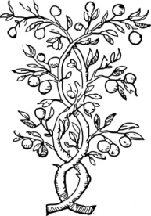
Root Words Lesson 4
Opposites

ROOT DEFINITION OF ROOT

contra against
contraband= goods that are illegally imported or exported

pro for, forward, ahead
procedure= a method of going forward or accomplishing something

belli war; quarrel
belligerent= hostile, ready to start a fight

pac peace
pacify= to calm somebody who is angry or agitated

phil love
bibliophile= a lover or collector of books

miso hate
misapodysis= the hatred of undressing in front of anyone

bene good/ well
benefactor= somebody who aids a cause, especially with a gift of money

mal bad
maladroit= showing lack of skill, clumsy or insensitive in speech or behavior

hetero other, different
heterodox= disagreeing with established opinions

homo same
homogenize= to make uniform or similar

