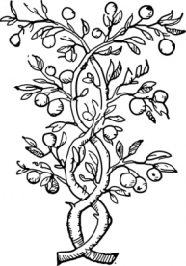
Root Words Lesson 5
Justice

ROOT DEFINITION OF ROOT

crim fault, accusation
incriminate=make appear guilty, accuse of wrongdoing

jud judge
judicable= suitable for trial, capable of being judged

jur swear, law
abjure= to swear away under oath

leg, legis law (collect)
legislature=body of lawmakers

liber free
liberty=freedom, right to choose

mag, maj, max, magn great
magnify= increase size or importance of something
majesty= awesomely large or great splendor

ques, quis question
inquisitive=inquiring, eager for knowledge

test witness
testimonial=statement backing up a claim

ver true, truth
verdict= a judgment, opinion or conclusion about something

vict conquer, overcome
victimize= to treat unfairly

